Term - 2 ==&Gt; CCNA - Network Fundamentals

1. Which of the following messages in the DHCP process are broadcasted?

Ans: A. Request

B. Offer

1. Which command would you use to ensure that an ACL does not block web-based TCP traffic?

Ans: B. permit TCP any any eq 80

# Explain Network Topologies

Ans:

Topology: A physical arrangement of devices.

**Bus Topology**: A bus topology is a network setup where all computers and devices are connected to a single central cable.

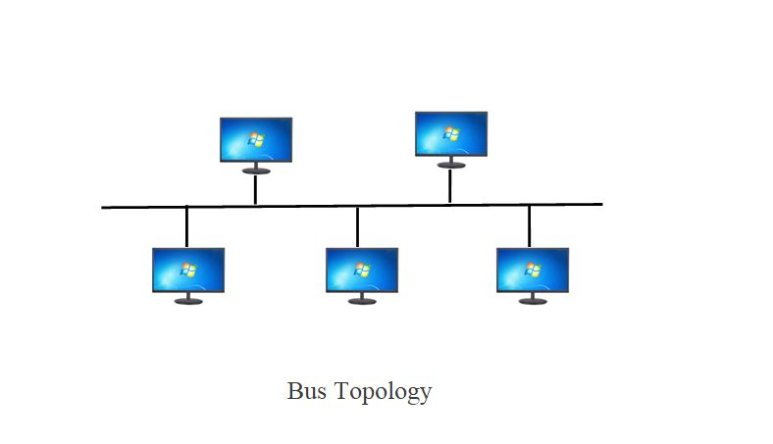

**Star Topology**: A star topology is a computer network topology where all nodes are connected to a central hub (or switch) node. Data travels only in one Direction.

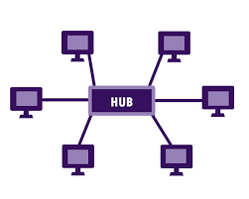

**Ring Topology**: A ring topology is a type of network topology in which each device is connected to exactly two other devices, forming a ring.

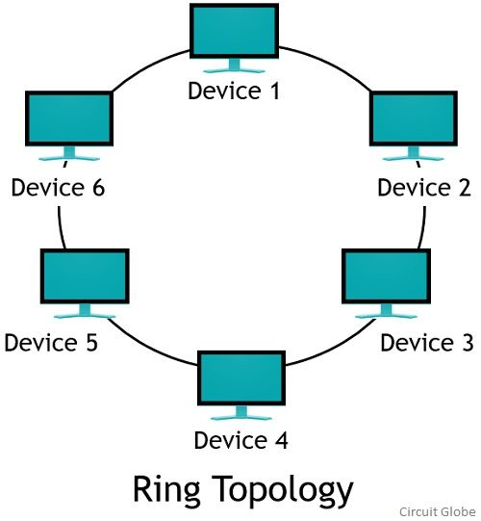

**Tree Topology**: Tree topology is a hierarchical network structure that combines characteristics of star and bus topologies.

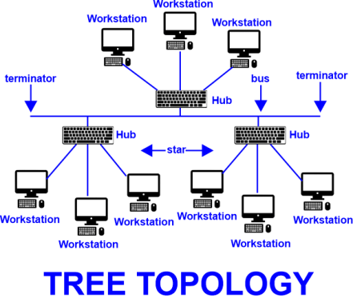

**Mesh Topolog**y: Mesh topology is a network configuration where each device is connected to every other device in the network. This creates multiple paths for data to travel.

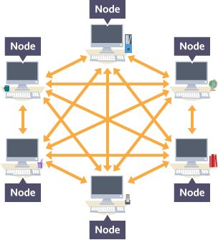

**Hybrid Topology**: A hybrid topology can be a combination of bus topology, ring topology and mesh topology.

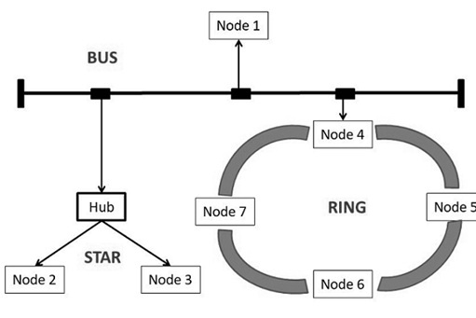

# Explain TCP/IP Networking Model.

Ans:

**Application Layer**

**Transport Layer**

**Internet Layer**

**Network Layer**

TCP/IP Stands for Transmission Control Protocol/Internet Protocol

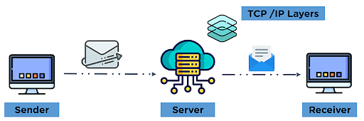

* + **Application Layer**:

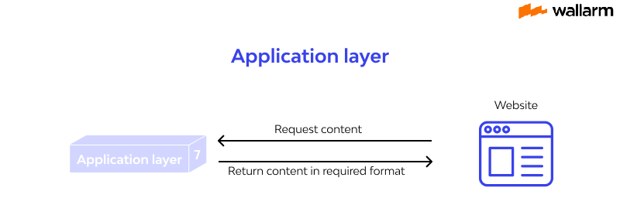

Provides network services directly to end-users and applications. The application layer maintains a smooth connection between the application and user for data exchange and offers various features as remote handling of the system, e-mail services, etc. Some of the protocols used in this layer are: HTTP, SMTP, FTP,NTP, and DNS.

* + **Transport Layer:**

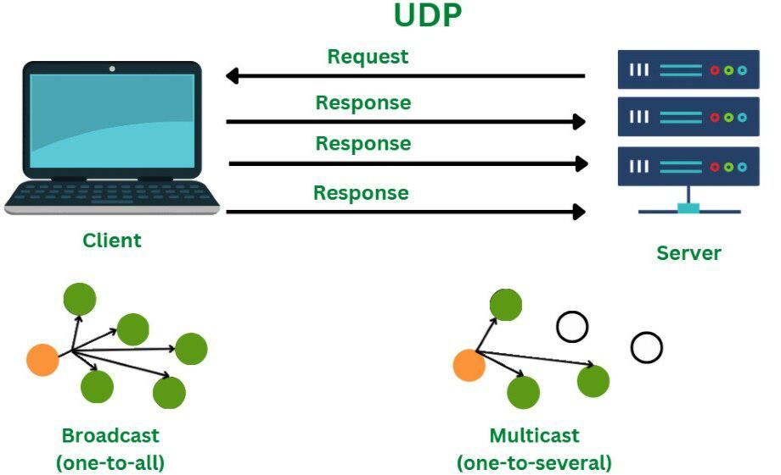

It also performs the task of maintaining the data, i.e., to be transmitted without error, and controls the data flow rate over the communication channel for smooth transmission of data. The protocols used in this layer are: TCP ( Transmission) Control Protocol, UDP( User Datagram Protocol)

* + **Internet Layer**:

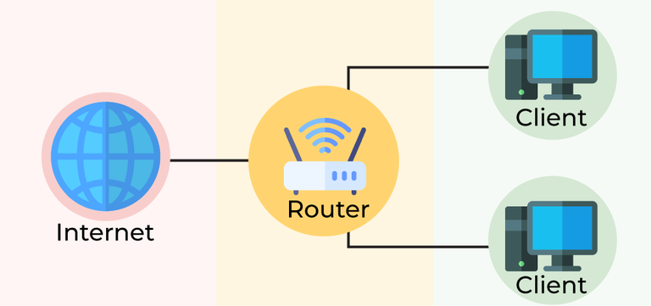

This layer is Handles logical addressing, routing, and forwarding of data packets across network boundaries. Some of the protocols applied in this layer are: IP (Internet Protocol), ICMP (Internet Control Message Protocol), ARP (Address Resolution Protocol).

* + **Network Layer:**

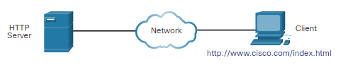

This layer is the combination of data-link and physical layer, where it is responsible for maintaining the task of sending and receiving data in raw bits, i.e., in binary format over the physical communication modes in the network channel.

# Explain LAN and WAN Network.

# Ans:

LAN(Local Area Network)

LAN is a network that usually connects a small group of computers in a given geographical area, such as a home, office, or school campus

WAN(Wide Area Network)

The WAN network spans to an even larger locality. It has the capacity to connect various countries together, such as a city, state, or country.

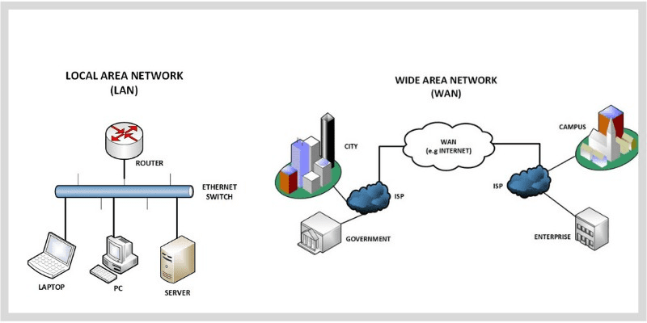

# Explain Operation of Switch.

Ans:

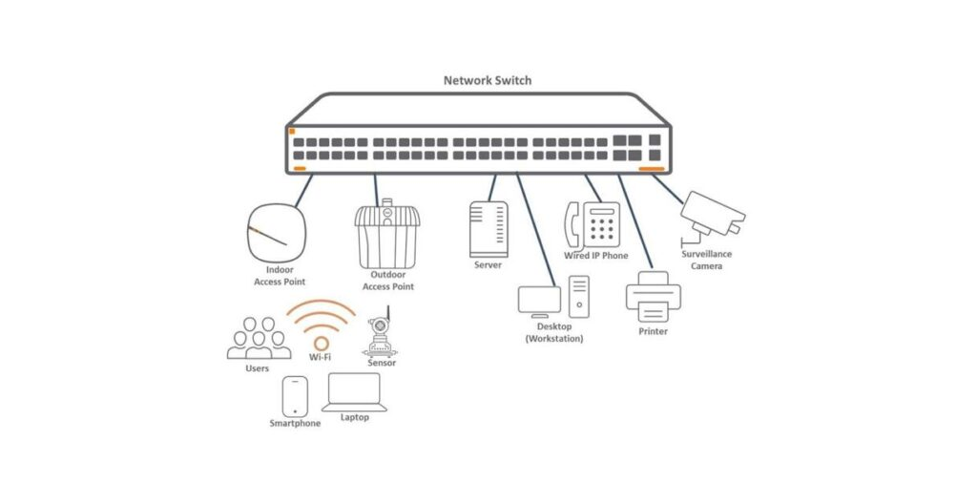

* Network switch forwards data to one or multiple devices that need to receive it.
* Switches are the multiport network bridges that process and forward data at the data link layer (layer 2 of OSI model).
* The switches that process data at the network layer or above it, known as layer 3 switches or multi-layer switches.
* Switches are also used in SOHO(Small Office/Home Office) applications that typically uses a single switch to access the various broadband services and the services like voice over internet protocol.

# Describe the purpose and functions of various network devices.

# Ans:

* + Router: A router is a device that connects different networks and directs data between them. Router devices have multiple network interfaces and can operate at different layers of the OSI model.
  + Hubs:A hub is a simple, less intelligent, and inexpensive networking device that is used for sending frames/frames from one device to rest of devices that are connected to the hub.
  + Switch: A switch is a network device that connects devices within a local area network (LAN), operating at the data link layer (Layer 2) of the OSI model. It receives incoming data packets, processes them, and forwards them to the appropriate device based on MAC (Media Access Control) addresses.
  + Bridge: Bridge in computer network is a smart device that is used for creating one bigger network by connecting smaller subnetworks. It can work as a repeater for extending the network. Operating at the data link layer (Layer 2) of the OSI model, a bridge filters traffic by examining MAC ad dresses, forwarding data packets only to the segment containing the destination address.
  + Modem: A modem is a type of network device that helps devices in getting connected with internet. It converts digital data in a suitable format for analogue transmission. This device has different types that can be installed according to the your data requirement.
  + Access Point (Wi-Fi): A network access point is a device that creates a Wireless Local Area Network (WLAN) that devices can connect to. Access points are connected to a central wired router or switch, and they act as a portal through which devices connect to the larger Wi-Fi network.

# Make list of the appropriate media, cables, ports, and connectors to 8-

# Ans:

# Media Types

# Twisted Pair Cable (UTP/STP)

# Coaxial Cable

# Fiber Optic Cable

# Wireless Media (Radio Waves, Microwaves)

# Cables

# Ethernet Cable (Cat5e, Cat6, Cat6a, Cat7, Cat8)

# Coaxial Cable (RG6, RG59)

# Fiber Optic Cable (Single-mode, Multi-mode)

# USB Cable (Type-A, Type-B, Type-C)

# Ports

# Ethernet Ports (RJ45)

# Coaxial Ports (F-Type)

# Fiber Optic Ports (SC, LC, ST)

# USB Ports (Type-A, Type-B, Type-C)

# HDMI Ports

# Serial Ports (RS-232)

# Audio/Video Ports (3.5mm Jack, RCA)

# Power Ports (DC, AC)

# Connectors

# RJ45 Connectors (used with Ethernet cables)

# USB Connectors (Type-A, Type-B, Type-C)

# RJ45 Connectors (used with Ethernet cables)

# 

1. Define network devices and hosts.

Ans:

Network Devices: Network devices are hardware components that enable communication and data exchange within a network. Examples of network devices include routers, switches, and access points.

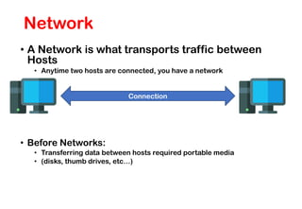

Host: Hosts are devices or computers connected to a network that use and provide network resources and services. Each host has a unique network address.

Host are any devices which sends or receive traffic

Examples of hosts include computers, smartphones, and servers.

